DBMS LAB #6
Exercise 1:
Query:
Select TeacherName, format(TeacherDOJ,’dd/MM/yyyy’) from Teacher
Where Job = (select job from teacher where TeacherName = ‘Dr. Khalid’)
Output:
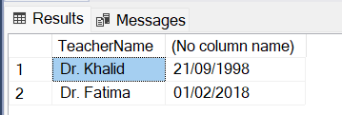

Exercise 2:
Query:
select TeacherID, TeacherName, BasicSalary from Teacher
where Job = (select job from teacher where TeacherID = 7)
Output:
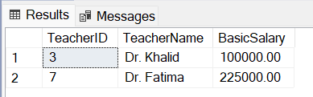

Exercise 3:
Query:
Select TeacherID, TeacherName
FROM Teacher
where BasicSalary > (
SELECT AVG(BasicSalary) from Teacher
)
ORDER BY BasicSalary DESC;
Output:
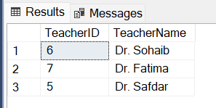

Exercise 4:
Query:
SELECT TeacherID, TeacherName, Job
FROM Teacher
WHERE BasicSalary > (
SELECT BasicSalary FROM Teacher
WHERE TeacherName = 'Dr. Safdar'
);
Output:
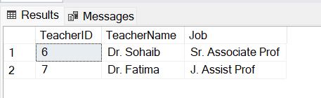

Exercise 5:
Query:
SELECT TeacherName, BasicSalary
FROM Teacher
WHERE Manager = (
SELECT TeacherID
FROM Teacher
WHERE TeacherName = 'Dr. Safdar'
);
Output:
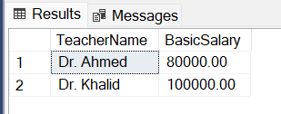

Exercise 6:
Query:
SELECT DISTINCT t.TeacherName, t.Job
FROM Teacher t
LEFT JOIN StdCourseTeacher sct ON (t.TeacherID = sct.TeacherID)
LEFT JOIN Course c ON (sct.CourseID = c.CourseID)
LEFT JOIN Prog p ON (c.ProgID = p.ProgID)
WHERE p.ProgID = (
SELECT DISTINCT p.ProgID
FROM Teacher t
LEFT JOIN StdCourseTeacher sct ON (t.TeacherID = sct.TeacherID)
LEFT JOIN Course c ON (sct.CourseID = c.CourseID)
LEFT JOIN Prog p ON (c.ProgID = p.ProgID)
WHERE t.TeacherID = 2
)
AND t.BasicSalary > (
SELECT BasicSalary
FROM Teacher
WHERE TeacherID = 7
);

Output:


Exercise 7:
Query:
SELECT DISTINCT t.TeacherName, t.TeacherID, p.ProgID
FROM Teacher t
LEFT JOIN StdCourseTeacher sct ON (t.TeacherID = sct.TeacherID)
LEFT JOIN Course c ON (sct.CourseID = c.CourseID)
LEFT JOIN Prog p ON (c.ProgID = p.ProgID)
WHERE BasicSalary < (
SELECT MIN(BasicSalary)
FROM Teacher t
LEFT JOIN StdCourseTeacher sct ON (t.TeacherID = sct.TeacherID)
LEFT JOIN Course c ON (sct.CourseID = c.CourseID)
LEFT JOIN Prog p ON (c.ProgID = p.ProgID)
WHERE p.ProgID = 2
);

Output:


Exercise 8:
Query:
SELECT TeacherID, TeacherName, Job
FROM Teacher
WHERE BasicSalary > (
SELECT AVG(BasicSalary)
FROM Teacher
);
Output:
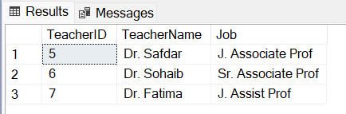
Exercise 9:
Query:
SELECT * FROM Teacher
WHERE BasicSalary > ALL (
SELECT BasicSalary
FROM Teacher
WHERE Job = 'J. Assist Prof'
)
ORDER BY BasicSalary DESC;
Output:

